**Assignment No. 7**

**YOLO Object Detection**

**1. Problem Statement:**

Object detection using YOLO and Pretrained Model.

**Objectives:**

1. To understand and implement the YOLO (You Only Look Once) algorithm for object detection using a pretrained model.
2. To apply YOLO to identify multiple objects in images or videos and classify them with high speed and accuracy.
3. To explore real-world applications such as autonomous driving, surveillance, and real-time object tracking.

**Theory:**

**Object detection** involves identifying and localizing objects within an image or video. Unlike classification, which only identifies the class of an object, object detection also determines the position (bounding box) of the object within the image.

**YOLO (You Only Look Once)** is a state-of-the-art object detection algorithm known for its speed and accuracy. It frames object detection as a single regression problem, directly predicting the bounding boxes and class probabilities from the image in one evaluation. Unlike traditional methods that involve multiple stages (like region proposal, classification, and bounding box refinement), YOLO processes the entire image at once, making it faster than other object detection approaches like R-CNN and Faster R-CNN.

**Methodology:**

1. **Data Collection**:
   * Use existing datasets such as COCO, PASCAL VOC, or custom datasets for object detection.
   * For real-time applications, feed live video streams into the model.
2. **Preprocessing**:
   * Resize input images to the size expected by the YOLO model (e.g., 416x416 pixels).
   * Normalize pixel values and ensure the aspect ratio is maintained.
3. **Model Loading**:
   * Load a pretrained YOLO model (e.g., YOLOv3, YOLOv4, YOLOv5) trained on a large dataset like COCO.
   * Use a framework like Darknet, TensorFlow, or PyTorch to implement the model.
4. **Object Detection**:
   * Pass the preprocessed image to the YOLO model.
   * YOLO divides the image into an SxS grid and predicts bounding boxes, object confidence scores, and class probabilities for each grid cell.
   * Non-Maximum Suppression (NMS) is applied to filter overlapping bounding boxes and retain only the best prediction for each object.
5. **Postprocessing**:
   * Draw the bounding boxes and labels on the image or video stream.
   * Display the confidence score for each detected object along with the bounding box.
6. **Deployment**:
   * Deploy the trained model to detect objects in real-time from video feeds or static images.

**Working Principle / Algorithm:**

1. **Grid Division**: YOLO splits the input image into an SxS grid. Each grid cell is responsible for detecting objects whose center falls within the cell.
2. **Bounding Box Prediction**: Each grid cell predicts multiple bounding boxes along with confidence scores that represent how confident the model is that a bounding box contains an object.
3. **Class Probability**: YOLO also predicts the class probabilities for each bounding box.
4. **Single Forward Pass**: Unlike other detectors that use region proposals, YOLO makes predictions in a single forward pass of the neural network, leading to faster inference times.
5. **Non-Maximum Suppression**: After detecting multiple bounding boxes, the algorithm applies NMS to filter out boxes with high overlap, keeping only the best prediction for each object.
6. **Output**: The final output consists of bounding boxes, class labels, and confidence scores for the detected objects.

**Advantages:**

1. **Real-Time Performance**: YOLO’s architecture allows it to detect objects at high frame rates, making it ideal for real-time applications such as surveillance and autonomous driving.
2. **End-to-End Learning**: YOLO trains the entire model end-to-end, leading to a more streamlined and efficient learning process.
3. **Generalization**: YOLO generalizes well to new domains and performs robustly on images outside its training set.
4. **Speed and Efficiency**: YOLO is significantly faster than traditional object detection methods like R-CNN, making it suitable for resource-constrained environments.

**Disadvantages / Limitations:**

1. **Localization Errors**: YOLO may struggle with the precise localization of small objects because it processes the entire image at once. Smaller objects may not always be detected accurately.
2. **Lower Recall for Small Objects**: Due to its grid-based approach, YOLO may miss detecting small objects in crowded scenes.
3. **Trade-off Between Speed and Accuracy**: While YOLO is fast, this can sometimes come at the cost of slightly lower accuracy compared to more complex, multi-stage detectors like Faster R-CNN.
4. **Sensitivity to Object Overlap**: YOLO’s performance can degrade when objects are heavily overlapping, as it relies on a fixed grid structure.

**11. Diagram:**

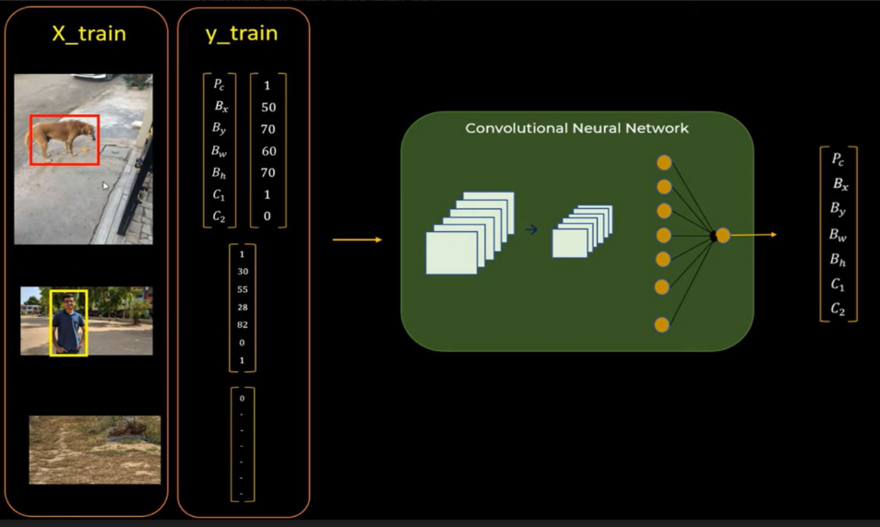

**12. Conclusion:**

* Object detection using YOLO and pretrained models allows for efficient and effective identification of objects in images and videos. By leveraging the speed and accuracy of YOLO, various real-time applications are possible. This practical assignment demonstrates the implementation of YOLO for detecting multiple objects with high accuracy. Despite some limitations in detecting small or overlapping objects, YOLO remains a popular choice for object detection tasks in diverse fields.